**Supplementary materials**

*Epidemiol Health Data Insights. 2025;1(1):ehdi003*

**Predictors of All-cause Mortality among Stroke Patients in Kazakhstan: A Retrospective Study Using Integrated AI Data Extraction**

Artem Yermakov1*, Kamila Akzholova1*, Temirgali Aimyshev1, Iliyar Arupzhanov1, Gulnur Zhakhina1, Abduzhappar Gaipov1

1*Department of Medicine, School of Medicine, Nazarbayev University, Astana, Kazakhstan*

* These author authors equally contributed to this article

Supplementary table 1. Number of missing values of each parameter.

|  |  |
| --- | --- |
| **Parameter** | **Number of missing values** |
| Serum creatinine, μmol/l | 83 |
| ALT, U | 118 |
| APTT, seconds | 126 |
| AST, U | 126 |
| Total bilirubin, μmol/l | 89 |
| Fibrinogen, g/l | 127 |
| Hemoglobin, g/l | 56 |
| Hematocrit, % | 157 |
| Leukocytes, *10^9/l | 56 |
| INR | 124 |
| Potassium, mmol/l | 185 |
| Blood protein, g/l | 119 |
| PTI, % | 138 |
| PTT, seconds | 167 |
| Sodium, mmol/l | 191 |
| ESR, mm/h | 91 |
| Blood sugar, mmol/l | 64 |
| Urine protein, g/l | 80 |
| Urea, mmol/l | 86 |

Supplementary table 2. Age difference between Russian and Kazakh patients.

|  |  |  |  |  |  |
| --- | --- | --- | --- | --- | --- |
|  | Ethnicity | | | | P-value  (T-test) |
| Russian | | Kazakh | |
| Mean | St. dev. | Mean | St. dev. |
| Age | 66.94 | 12.17 | 58.77 | 13.82 | <0.0001 |

Supplementary table 3. Crude Cox regression analysis.

|  |  |  |  |
| --- | --- | --- | --- |
| Characteristics | Number of observations/ numbers of death | Unadjusted HR  [95% CI] | **p value** |
| Age | 272 / 126 | 1.04 [1.02; 1.06] | **0.000** |
| Gender  Male  Female | 133/ 58  139/ 68 | 0.87 [0.61; 1.23] | **0.427** |
| Ethnicity  Kazakh  Russian  Others | 146/ 55  75/ 70  52/ 1 | 1.55 [1.15; 2.08] | **0.004** |
| Dexamethasone | 27/ 13 | 1.12 [0.62; 2.02] | **0.708** |
| Dopamine | 14/ 11 | 4.46 [1.64; 12.13] | **0.003** |
| Magnesium sulphate | 155/ 68 | 0.82 [0.58; 1.17] | **0.282** |
| Fraxiparine | 19/ 4 | 0.37 [0.14; 0.99] | **0.049** |
| Actovegin | 141/ 67 | 1.04 [0.73; 1.48] | **0.843** |
| Cerebrolysin | 32/ 13 | 0.89 [0.49; 1.63] | **0.702** |
| Vinposan | 61/ 30 | 1.06 [0.71; 1.59] | **0.782** |
| Piracetam | 133/ 69 | 1.29 [0.91; 1.86] | **0.153** |
| Strocitus | 62/ 23 | 0.70 [0.45; 1.10] | **0.123** |
| Serum creatinine | 189/ 89 | 1.00 [1.00; 1.00] | **0.031** |
| ALT | 154/ 75 | 0.99 [0.98; 1.01] | 0.424 |
| aPTT | 146/ 66 | 0.99 [0.98; 1.02] | 0.891 |
| AST | 146/ 70 | 0.99 [0.98; 1.01] | 0.399 |
| Total bilirubin | 183/ 82 | 0.99 [0.98; 1.02] | 0.982 |
| Fibrinogen  Fibrinogen +5 | 145/ 62 | 1.14 [0.99; 1.29]  0.63 [-0.03; 1.29] | 0.061 |
| Hemoglobin | 216/ 95 | 0.98 [0.97; 0.99] | **0.009** |
| Hematocrit | 115/ 58 | 0.97 [0.91; 1.03] | 0.380 |
| Leukocytes  Leukocytes +5 | 216/ 95 | 1.03 [0.97; 1.09]  0.14 [-0.16; 0.45] | 0.351 |
| INR | 148/ 62 | 2.89 [0.90; 9.23] | 0.074 |
| Potassium | 87/40 | 0.78 [0.52; 1.16] | 0.221 |
| Blood protein | 153/ 68 | 0.98 [0.97; 1.01] | 0.260 |
| PTI | 134/ 64 | 0.98 [0.97; 0.99] | **0.045** |
| PTT | 105/ 44 | 1.00 [0.98; 1.02] | 0.941 |
| Sodium | 81/ 37 | 1.01 [0.95; 1.07] | 0.701 |
| ESR | 181/ 82 | 1.01 [0.99; 1.03] | 0.136 |
| Blood sugar  Blood sugar +5 | 208/ 93 | 1.05 [1.02; 1.08]  0.26 [0.11; 0.42] | **0.001** |
| Urine protein  Urine protein +5 | 192/ 84 | 1.15 [1.08; 1.24]  0.72 [0.38; 1.06] | **0.000** |
| Urea | 186/ 85 | 1.07 [1.05; 1.10] | **0.000** |

Supplementary table 4. Adjusted Cox regression.

|  |  |  |  |  |  |  |
| --- | --- | --- | --- | --- | --- | --- |
| Characteristics | Adjusted HR Model 1 | p value | Adjusted HR Model 2 (Model 1 + drug treatment)  [95% CI] | p value | Adjusted HR Model 3 (Model 2 + lab. tests)  [95% CI] | p value |
| Age | 1.035 [1.02; 1.05] | **0.000** | 1.036 [1.01; 1.05] | **0.000** | 1.03 [0.97; 1.09] | 0.357 |
| Gender | 0.937 [0.661; 1.329] | 0.717 | 0.86 [0.61; 1.23] | 0.427 | 0.62 [0.16; 2.37] | 0.484 |
| Nationality | 1.555 [1.173; 2.063] | **0.002** | 1.55 [1.15; 2.08] | **0.004** | 1.76 [0.98; 3.19] | 0.059 |
| Dopamine | - | - | 4.95 [2.10; 11.63] | **0.000** | 1 | - |
| Fraxiparine | - | - | 0.34 [0.14; 0.80] | **0.014** | 0.60 [0.09; 3.77] | 0.587 |
| Piracetam | - | - | 1.13 [0.78; 1.63] | 0.515 | 0.79 [0.29; 2.14] | 0.656 |
| Strocitus | - | - | 0.83 [0.52; 1.33] | 0.438 | 0.25 [0.03; 2.38] | 0.229 |
| Serum creatinine | - | - | - | - | 0.99 [0.98; 1.01] | 0.622 |
| Fibrinogen | - | - | - | - | 1.04 [0.58; 1.86] | 0.887 |
| Hemoglobin | - | - | - | - | 0.98 [0.95; 1.01] | 0.132 |
| INR | - | - | - | - | 0.01 [9.08e-09; 6523.415] | 0.485 |
| PTI | - | - | - | - | 0.94 [0.76; 1.17] | 0.591 |
| ESR | - | - | - | - | 1.01 [0.93; 1.10] | 0.806 |
| Blood sugar | - | - | - | - | 1.06 [0.93; 1.10] | 0.806 |
| Urine protein | - | - | - | - | 81.09 [0.00; 186] | 0.391 |
| Urea | - | - | - | - | 1.14 [0.90; 1.42] | 0.272 |

Supplementary figure 1. Age distribution among survived and deceased patients.

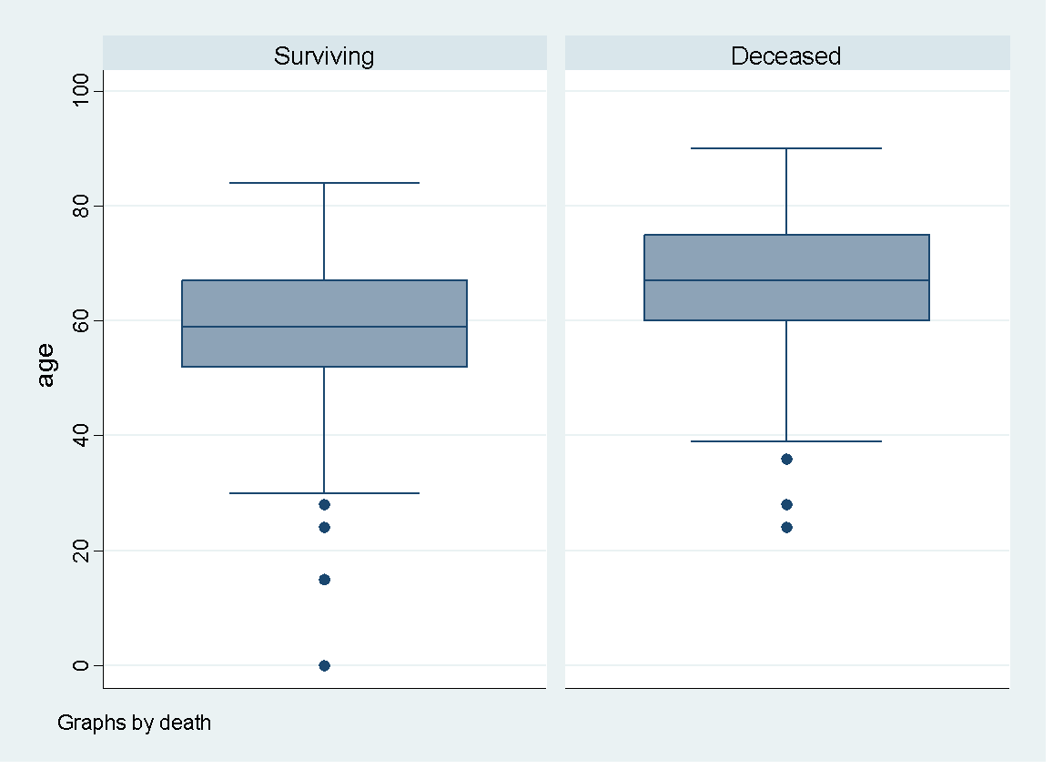

p < 0.0001

Supplementary figure 2. Hemoglobin levels among survived and deceased patients.

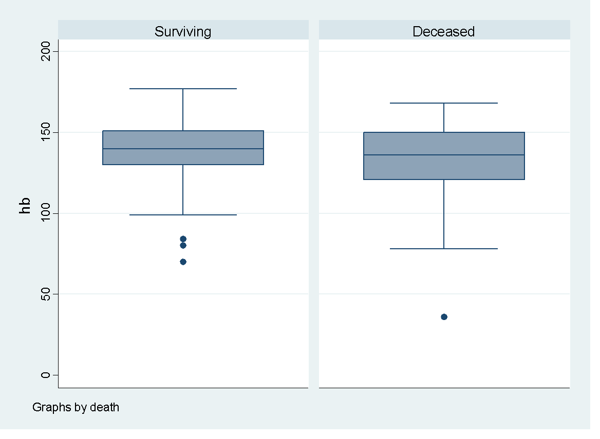

p = 0.0285

Supplementary figure 3. PTI distribution among survived and deceased patients.

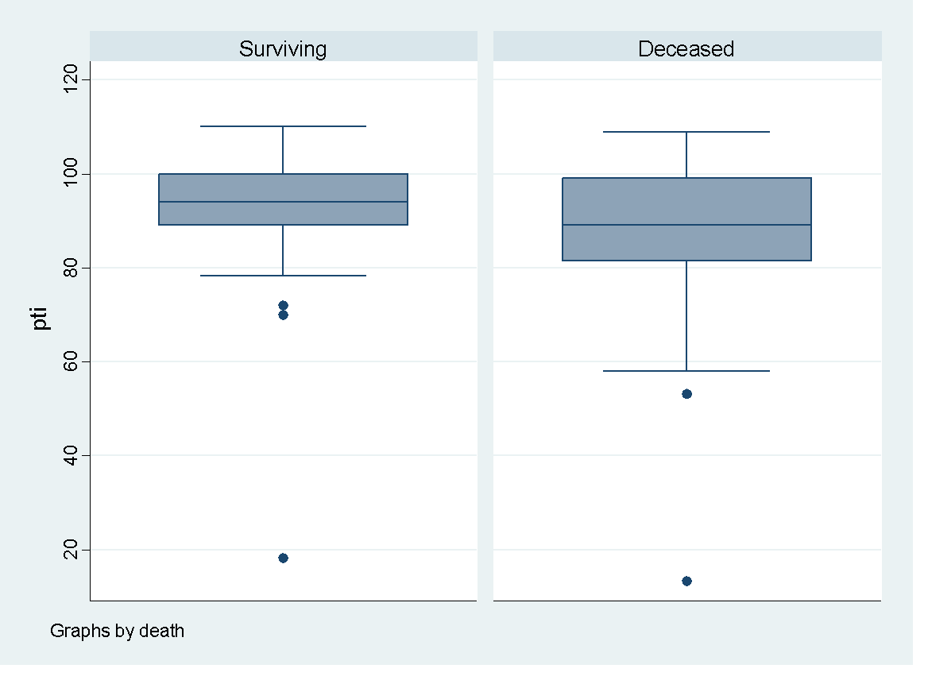

p = 0.0311

Supplementary figure 4. Kaplan-Meier survival analysis among stroke patients adjusted for age category.

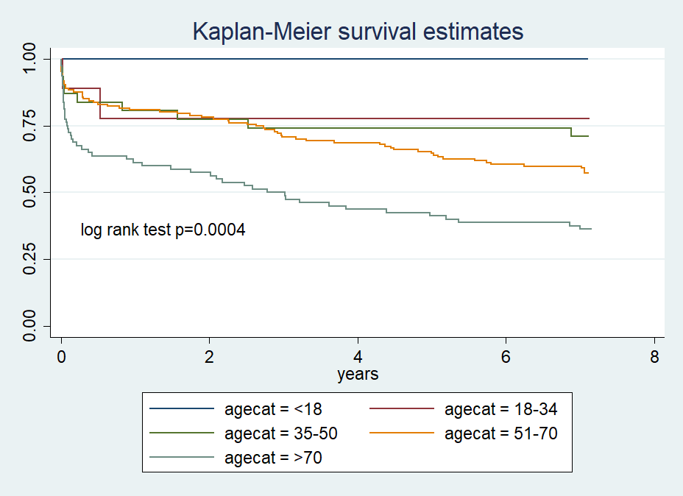

Supplementary figure 5. Kaplan-Meier survival analysis among stroke patients adjusted for gender.

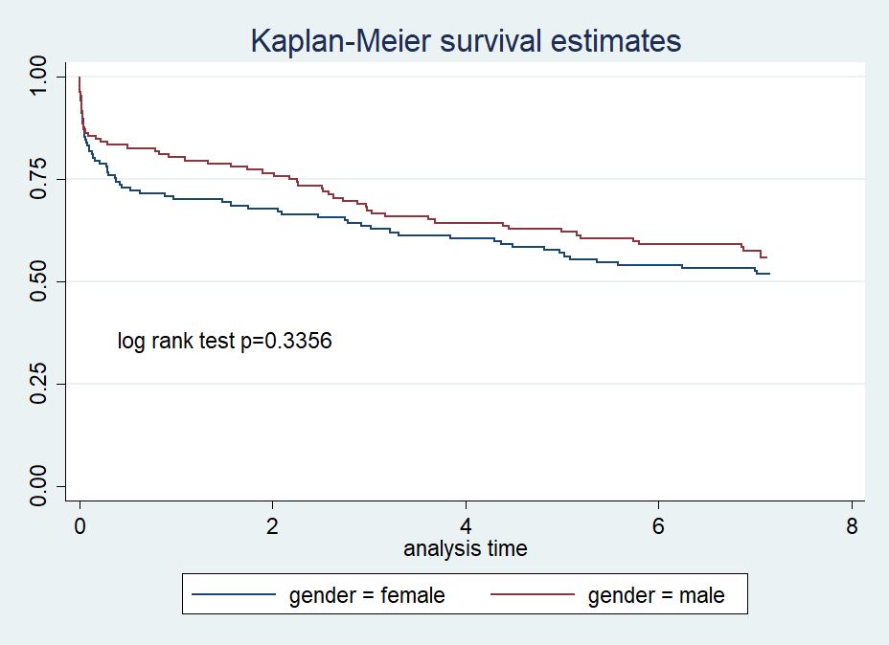

Supplementary figure 6. Kaplan-Meier survival analysis among stroke patients adjusted for nationality.

